# Phase 9: Reporting, Dashboards & Security Review Report

# 1: AI Suggestions Report

Objective:  
To generate a report that lists AI suggestions with their confidence scores, total records, and allows drill-down for detailed analysis.

## Steps Followed:

1. Login to Salesforce:  
    - Access Salesforce using your credentials.  
    - Navigate to the App Launcher and select the app where your AI Suggestions object exists (for example, “AI Collaboration Platform”).
2. Navigate to Reports Tab:  
    - Click on the Reports tab from the main navigation menu.  
    - Click New Report.
3. Select Report Type:  
    - In the “Choose Report Type” window, select the custom object AI Suggestions.  
    - Click Continue.
4. Configure Report Filters:  
    - Set Filters to include all records (or specific criteria if needed).  
    - Example: All AI Suggestions or filter by Created Date/Confidence Score as required.
5. Add Report Columns:  
    - Drag and drop relevant fields to the report:  
    - AI Suggestion Name  
    - Confidence Score  
    - Total Records  
    - Add subtotals by Confidence Score to summarize suggestions at each confidence level.
6. Sort and Group Data:  
    - Group by Confidence Score (ascending order).  
    - Enable drill-down by selecting each row to see detailed suggestions.
7. Save and Run Report:  
    - Click Save & Run.  
    - Provide the Report Name: “AI Suggestions”  
    - Save in the appropriate folder for access by relevant users.
8. Validation:  
    - Ensure total records, subtotals, and drill-down functionality are correctly displaying AI suggestions grouped by confidence score.  
   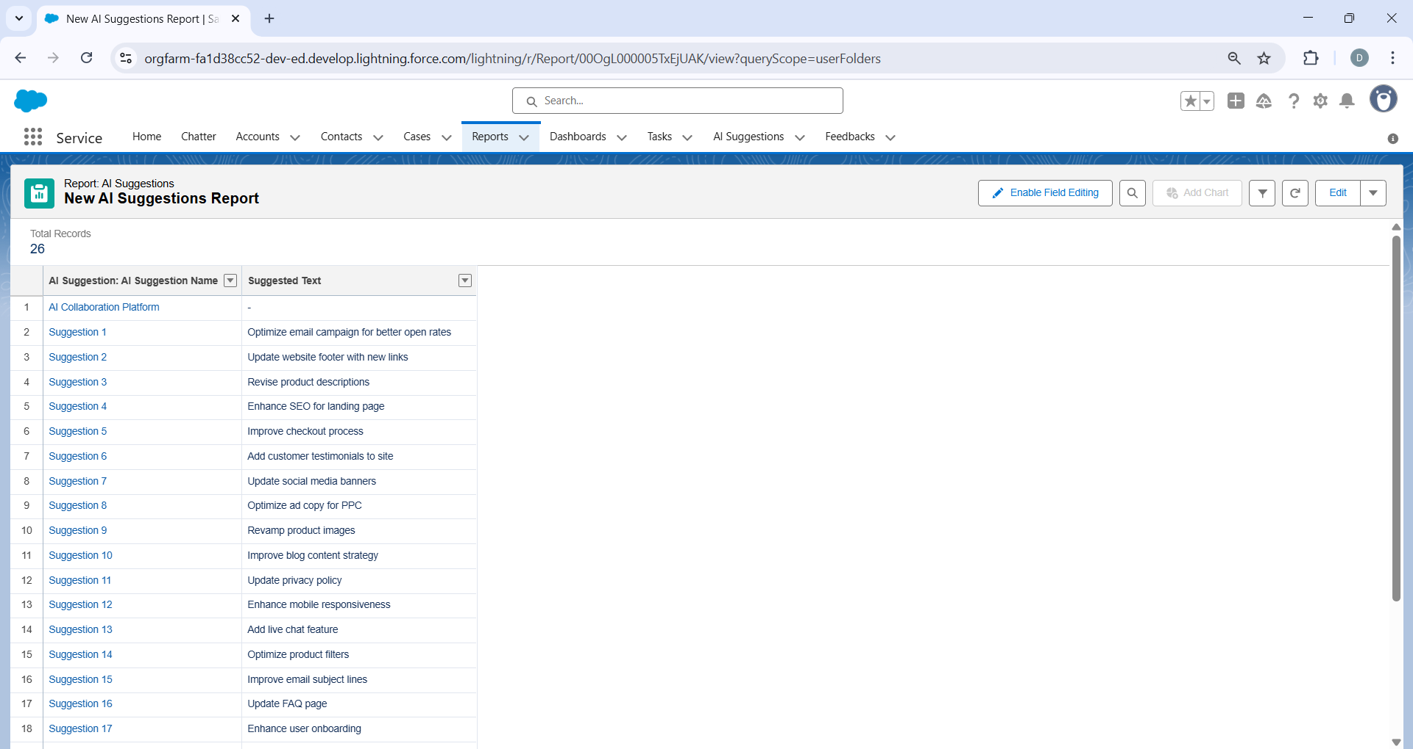

# Report 2: AI Suggestions with Feedback & Tasks

Objective:  
To generate a report that links AI suggestions with feedback and comments for better analysis of improvement areas.

## Steps Followed:

1. Login and Navigate to Reports:  
    - Access Salesforce and select the relevant app.  
    - Go to Reports → New Report.
2. Select Report Type:  
    - Choose the custom report type AI Suggestions with Feedback & Tasks.  
    - Click Continue.
3. Apply Filters:  
    - Set filters to display all records or based on specific criteria (example: “All Feedback Submitted”).
4. Add Relevant Fields:  
    - Include the following fields in the report:  
    - AI Suggestion Name  
    - Feedback Name  
    - Comments  
    - Suggested Text  
    - Enable Subtotal where necessary for grouped insights.
5. Sort Data:  
    - Sort by Suggested Text (ascending).  
    - Enable drill-down functionality to view each feedback or task linked to the suggestion.
6. Save and Run Report:  
    - Click Save & Run Report.  
    - Provide Report Name: “AI Suggestions with Feedback & Tasks”  
    - Choose an appropriate folder for storage.
7. Validation:  
    - Verify all 28 records are visible.  
    - Confirm that each AI suggestion correctly displays feedback, comments, and subtotals.

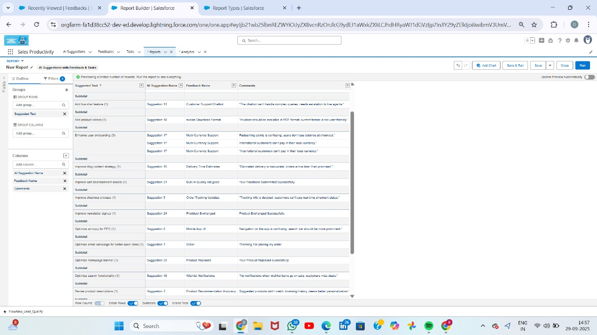

**Dashboards**1. Purpose & Overview

I created a Lightning dashboard in our Sales Productivity app to visualize AI suggestions and user feedback collected on the AiSuggestion and Feedbacks object. The dashboard contains two components:

* A Funnel chart showing counts by *Suggested Text* (visualizing top suggestions / feedback types).
* A Donut (ring) chart showing counts grouped by *Confidence Score* (visualizing confidence distribution for AI suggestions).

This document describes, step-by-step, how I prepared the data, built the reports, assembled the dashboard, and embedded the dashboard in the Lightning page so it is available inside the Sales Productivity app.

2. Prerequisites

Before starting I ensured:

* I have System Administrator or a profile with Report & Dashboard create/edit rights.
* The custom object AiSuggestion and Feedbacks (and fields such as Suggested Text and Confidence Score) is available and populated with sample records.
* I have access to the Sales Productivity Lightning app (to add the dashboard to the app page).

3. Data preparation

1. Verified the custom object records:
   * Confirmed that Suggested Text contains the free text or picklist values representing suggestion categories.
   * Confirmed that Confidence Score is a numeric or percentage field with values (the chart legend shows percentages such as 78%, 84%, 95% etc.).
2. If needed, created a Bucket Field or a formula on the report to group Confidence Score into ranges (optional). Example ranges: 0–69%, 70–79%, 80–89%, 90–100%.

4. Create the reports

I built two reports — one for the funnel and one for the donut chart.

Report A — *AI suggestion and Feedback & comments* (Funnel)

1. From the App Launcher, clicked Reports → New Report.
2. Chose the report type AiSuggestion and Feedbacks (custom object report type).
3. In the report builder:
   * Set filters (e.g., Date range, Status) as needed to scope records. For initial build I used *All Time* to include all records.
   * Added a grouping on Suggested Text (Group Rows by Suggested Text).
4. Added a chart to the report:
   * Clicked Add Chart → Chart type: Funnel (or if only available via dashboard component, I left grouping and used funnel type when adding to dashboard — both approaches work).
   * Value/Measure: Record Count.
   * Label: Show category names in legend (Suggested Text).
   * Saved the report with the name: AI suggestion and Feedback & comments and placed it in an appropriate folder (e.g., Sales Productivity Reports).

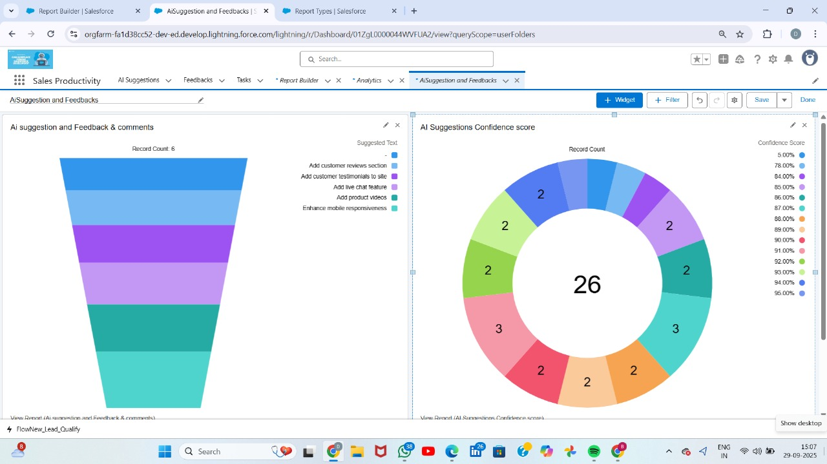

**Report B — *AI Suggestions Confidence score* (Donut)**

1. From Reports → **New Report**, selected **AiSuggestion and Feedbacks** report type again.
2. In the report builder:
   * Set filters the same as Report A for consistency.
   * Grouped rows by **Confidence Score** (or by Confidence Score bucket if created).
3. Added a chart:
   * **Donut** (or Pie with doughnut option) chart type.
   * Value/Measure: **Record Count**.
   * Enabled center summary to show the total count (e.g., the donut in the screenshot shows **26** in the center).
4. Saved the report as **AI Suggestions Confidence score** in the same folder.

**5. Create the Lightning Dashboard**

I assembled the dashboard that contains both charts side-by-side.

1. From the App Launcher, navigated to **Dashboards** → **New Dashboard**.
2. Entered Dashboard Title: **AiSuggestion and Feedbacks** (I added a descriptive subtitle if needed).
3. Saved into the **Sales Productivity** folder (or folder used by the team).
4. In the Dashboard Builder:
   * Clicked **+ Component**.
   * For the left component:
     + Selected **AI suggestion and Feedback & comments** report as the source.
     + Chose component type **Funnel chart** (if Funnel chart option is shown) or used the report chart as built.
     + Configured component to show **Record Count** and the grouping by **Suggested Text**.
     + Set component title: *Ai suggestion and Feedback & comments* (matching the report).
   * For the right component:
     + Clicked **+ Component** again.
     + Selected **AI Suggestions Confidence score** report.
     + Chose component type **Donut** (ring) chart.
     + Configured it to display grouping by **Confidence Score** (or buckets), with center total visible.
     + Set component title: *AI Suggestions Confidence score*.
   * Adjusted layout: placed both charts on the same row, sized each component equally for visual balance.
   * Optionally added component footers: “View Report” links so users can drill into underlying reports.
5. Clicked **Done** → **Save** (and optionally **Activate** / share settings).
6. Confirmed dashboard loads in Lightning and that both components reflect current data and counts.

**6. Add the Dashboard to the Lightning Page (Sales Productivity app)**

To make the dashboard visible inside the Sales Productivity app page, I embedded it with the Lightning App Builder.

1. Opened the **Sales Productivity** app and navigated to the page where I wanted the dashboard.
2. Clicked the gear icon (⚙) → **Edit Page** (this opens Lightning App Builder).
3. In Lightning App Builder:
   * From the left components list, searched for **Dashboard** and dragged the **Dashboard** standard component onto the page canvas where I wanted the dashboard to appear.
   * In the right properties pane for the Dashboard component:
     + Selected the dashboard: **AiSuggestion and Feedbacks (Enablement Dc...)** (the exact dashboard name appeared in the picklist).
     + Optionally set **Max Height** and enabled **Hide on Error**.
     + Configured component visibility rules if I wanted the dashboard visible only to certain profiles or users.
4. Clicked **Save** in App Builder, then **Activation** if I needed to set this page as the default for the Sales Productivity app or for specific profiles.
5. Returned to the Sales Productivity app and verified the dashboard is rendered correctly on the page.

**7. Final verification & user experience**

* Verified the funnel shows the breakdown of suggestions (Suggested Text) and the donut shows the confidence score distribution, matching the screenshots.
* Tested **drill-down**: clicked component footers **View Report** to ensure each component opens the underlying report.
* Set dashboard **Subscription** and **Sharing** (if required) so stakeholders receive updates.
* Optionally set automatic dashboard refresh intervals so data is up-to-date for viewers.

